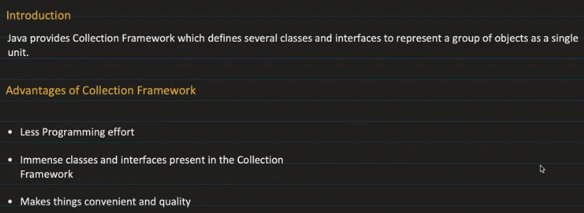

Array 🡪 Uniqueness(Add a particular thing ) / Size issues(size not present at the time of starting)/ Same data type

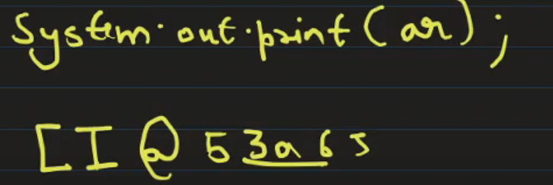 Class ID 🡪 I here is because of Integer

Map doesn’t extends Collection interface but is a part of Collection framework .

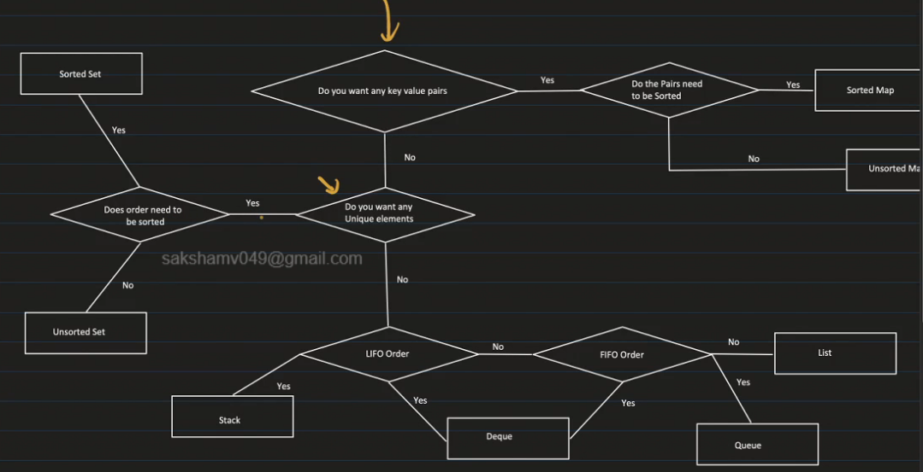

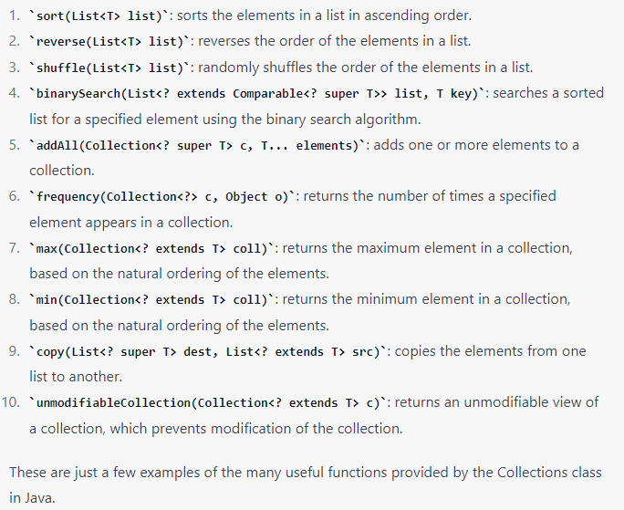

LIST

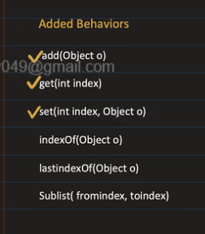Sublist(form,to)[from,to)

Default Cap of ArrayList and CurrentCap 🡪10

ArrayList 🡪

Currentcap = prevcap+ prevcap/2

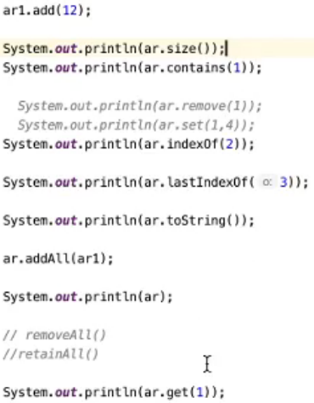

LIST

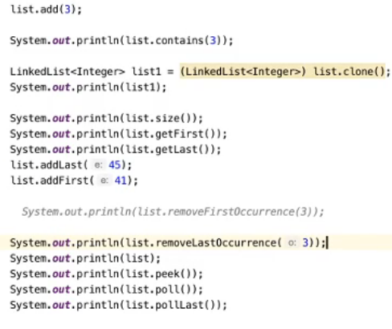

Vector 🡪

Currentcap = prevcap\*2

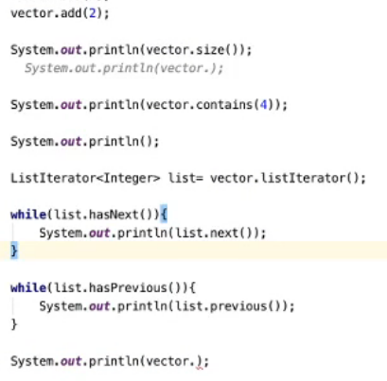

Vector<String> vector = new Vector<>();

vector.addElement("Apple");

vector.addElement("Banana");

vector.addElement("Cherry");

String secondElement = vector.elementAt(1);

System.out.println(secondElement);

Set and HashSet

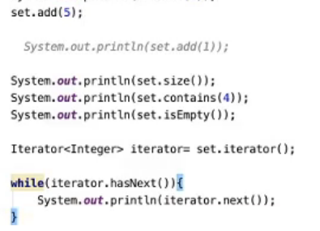

TreeSet

